Concurrency
PRJ311 – workshop1:
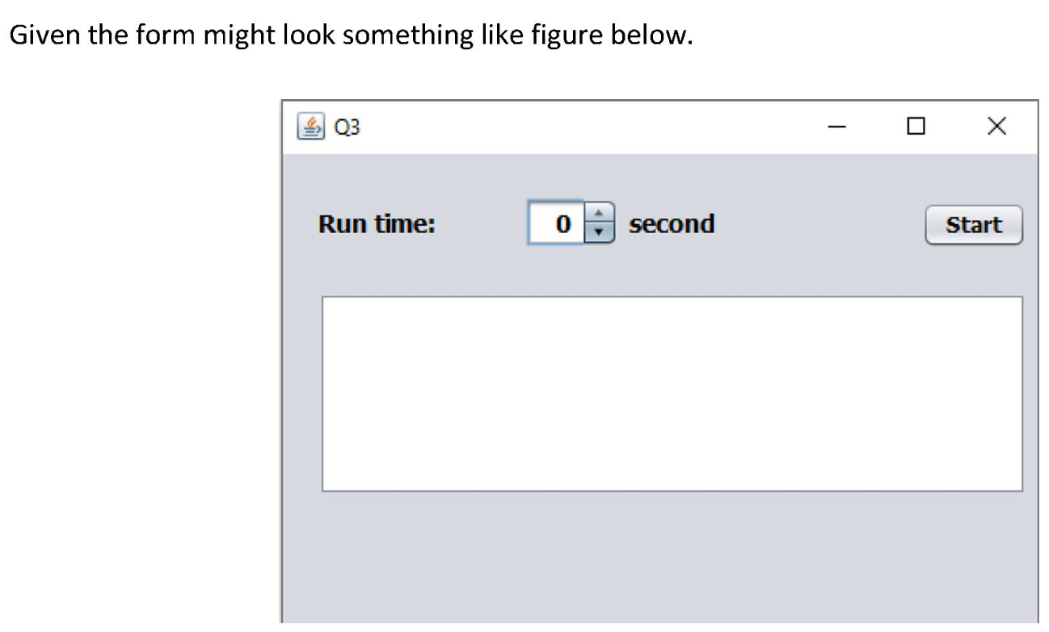

A user are allowed to enter/select a value of the spinner (call as time).
Create 2 threads (Thread1 and Thread2). When a user click the Start button:
- Thread1: Count down from time to 0 (in each second decreased by 1).
- Thread2: Appends prime numbers (each second appends 1 number).
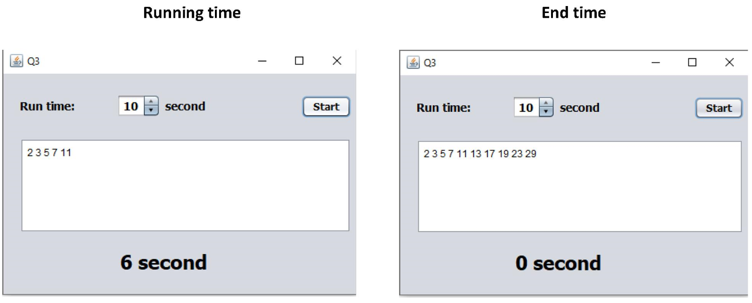
PRJ311 – workshop2:
Design the form which at running might look something like figure below:
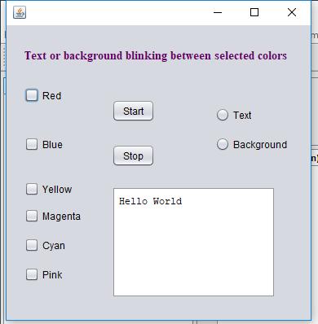
When running, a user can select colors. E.g. if a user select colors as below, then the clor of the title will change between Red -> Yellow -> Cyan -> Red ... in each second.
